1.Write php program, which changes the color of the first character of a word in a sentence.

2. Write a PHP program to compute the sum of the prime numbers less than 200

3.Get two input number using Text box ,Select operator using select option- use submit button to perform particular operation.

4. Study Of Form Handling In PHP- Design the personal information form ,submit and retrieve the form data using php $_POST,$_GET,$ REQUEST variable.

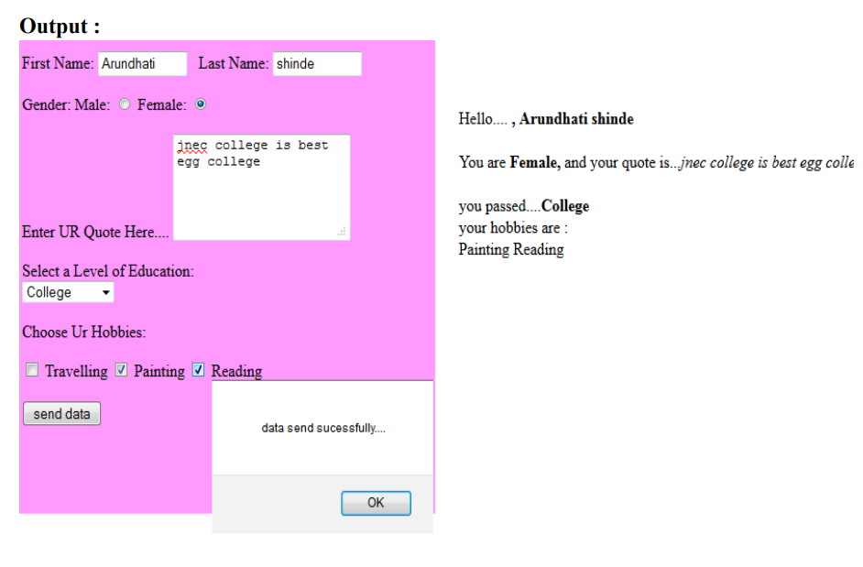

5. Create a webpage using PHP that consists of textboxes to read “empid,” “salary,” “eName,” and “address.” The webpage should consist of submit and reset buttons. The form should be directed to a php file to

a. Check whether empid is proper or not (length of empid must be 8, the first four places of empid must be characters and the remaining are digits)

b. Salary must contain digits only and number of digits should be in the range (4-6).

c. eName must have characters only. The first character has to be capital letter.

d. Display the length of the address on the webpage.